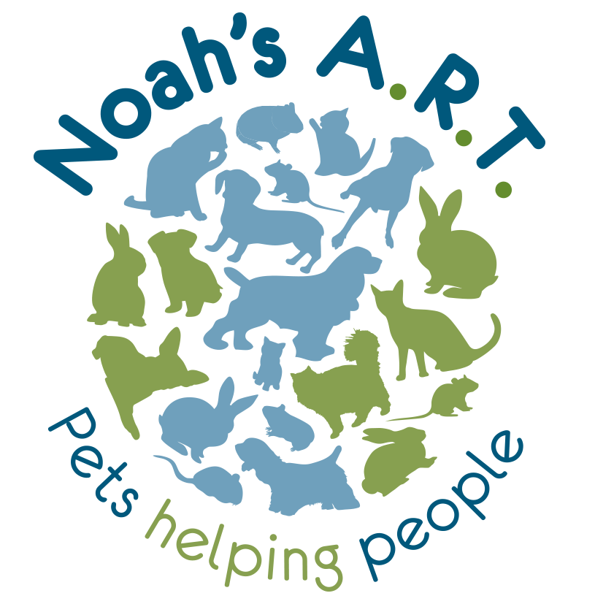
Tel: 07507399822 / 07505474390
www.noahs-art.co.uk

tom@noahs-art.co.uk or
catherine@noahs-art.co.uk

Volunteer Application Form

Any information given on this form is confidential and covered by the Data Protection Act 1998

Date Enquired:
Name: | Preferred Title: Mr/Mrs/Miss/Ms
D.O.B: | Tel. No:
Do you drive: Y/N | Do you have access to your own vehicle: Y/N
Address:

E-Mail:
Where did you hear about volunteering for Pet Connect:

Experience with animals:

Work and volunteering experiences:

Relevant courses or training:

Hobbies and Interests:

Why would you like to be a volunteer with Pet Connect:

Please indicate if you require any additional support to benefit from volunteering with us e.g. wheelchair access, support worker, training, transport:

Do you have any Criminal Convictions (other than minor driving offences): Yes / No
If yes, please state date and nature of conviction:

Approximately how much time would you like to give each week? Please indicate specific days or times:

Pet name: | Type of pet:
Tell us a little about your pet:

Please give two independent referees who would be willing to supply a character reference (these must not be family members)
Name | Name
Address | Address
Tel. no. | Tel. no.
Thank you for your interest. Please note that we do normally need two satisfactory references before you can start as a volunteer and we cannot always guarantee a suitable role. Some volunteering jobs will be subject to a satisfactory DBS/CRB police check.
Volunteer Application Form

Any information given on this form is confidential and covered by the Data Protection Act 1998

CONFIDENTIAL

Recruitment of Ex-Offenders – Pet Connect volunteer opportunities will involve direct contact with potentially vulnerable older people. As such, applications to volunteer are exempt from the Rehabilitation of Offenders Act 1974. This means that potential volunteers are required to declare their entire criminal record, including cautions, reprimands, and final warnings and criminal convictions categorised `spend’ under the above legislation.

Please complete and sign this section. The information provided will be kept confidential. It will only be disclosed to specific Noah’s ART staff if/when they are considering you for specific volunteering opportunities (where you may come into contact with potentially vulnerable adults). Volunteer opportunities are available working directly with the animals.

Have you ever been convicted at a Court or Cautioned by the Police for any offence?

Yes/No (Delete as appropriate).

If Yes, please give details, including date(s) and nature of offence(s).

…………………………………………………………………………………………………………………

…………………………………………………………………………………………………………………

I declare the above information is correct

Full Name: …………………………………………………………………………………………………

Signature: ……………………………………………………. Date: …………………………………

Once completed please either email this form to tom@noahs-art.co.uk or post to: Noah’s A.R.T., Loxley House, 287 Birch Lane, Dukinfield, SK16 5AU.

